**Troubleshoot Network Issues Using Page Load Analyzer**

Ericom Shield includes a Page Load Analyzer tool, used to measure the page loading time. This tool can help identify network issues when pages take too long to load and can also pin-point the root cause of these issues.   
  
The results of the analyzer (described hereunder) may vary based on the website, network conditions etc.   
It is recommended to run the analyzer from **two** different end users computer - one which is considered as a proper baseline (performance-wise) and a second, which is slower or has performance issues – and then compare the results.

Note: It is recommended to analyze common and often used URLs, which do not redirect, meaning – to check the final URL. Each redirection includes additional events, takes more time and the results may be harder to understand.

To use the Page Load Analyzer, open a Shield browser and go to <http://shield-perf/>:

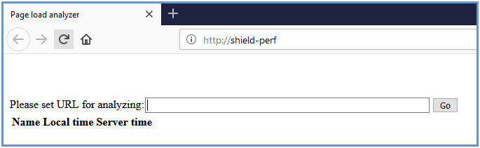

Enter the URL to analyze and click “Go”

The results received include the different events in the browsing process, the time each event took and a frame showing the actual website. The events duration may indicate the “problematic” step along the process.

After the page is analyzed, the results are displayed:



**Reading The Analyzer Results**

The results can be divided into 2 segments: **End user browser to Shield proxy** (marked in yellow) and **Remote browser to the Internet** (marked in blue)**.**

The first segment (in yellow) starts with the user getting the AN html page, then the needed JavaScript, then a WebSocket connection is done to the remote browser (end of first segment).

If this segment is slow (more than 2s), investigate these options:  
  
1. **Slow communication between the end user browser and shield proxy**  
Sometimes a local AV or a local FW, between the user and the proxy, which inspects the communication, or any other inspection tool, may result in significant slowness. To verify if this is the case, use a browser that connects directly to the proxy (disable the AV, FW etc.).

2. **Slow DNS resolution**The proxy does a DNS resolution of the URL. If the DNS is slow, it may delay page loading. This can be tested via the analyzer tool in the admin (port 8185). In case the internal DNS servers causes the slowness, try to set other DNS like google or others.

3. **Slow categories detection (when Categories are enabled in the system)**The proxy does a request to get the proper categories per URL. If this communication is slow, the page load will be slow. To verify if this is the case, use the <http://shield-cat/> page and check the query time it takes to get the categories. It should be less then 300ms in most cases.

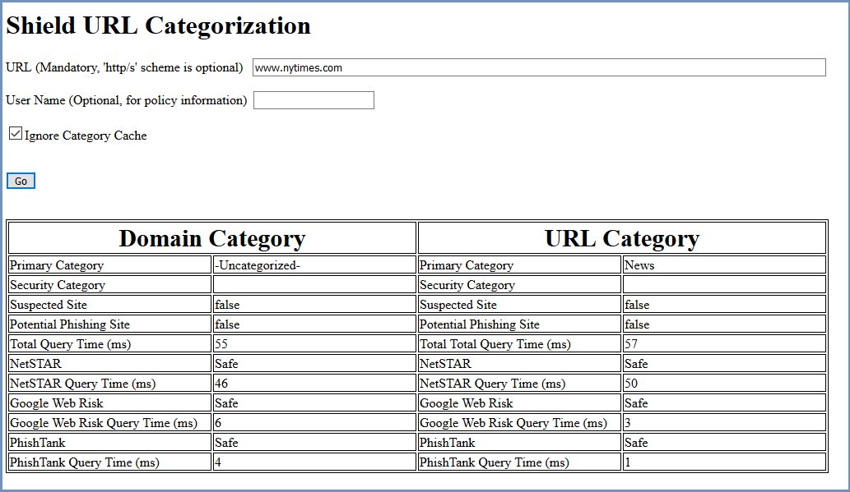

If this is not the case, investigate the root cause of the slow connection to the Categories server.

The second segment in the process (in blue) is the **Remote Browser** to the **Internet**.   
The **Got Policy Info** & **Navigating to URL** events are received the first time that the remote browser renders the web page. Then, once the **Client_firstImageRecieved** event is issued, an initial image appears in the remote page. The next event is **Client_domReadyEventReceived -** when the remote browser got Dom Ready. The last event is **Client_mainFrameLoadedEventReceived**, when all page resources are received and the page is completely loaded.  
  
For a good user experience, the **Client_firstImageRecieved** event should appear after about 3-5 sec and the **Client_mainFrameLoadedEventReceived** event should appear after about 5-10 sec.  
  
If this segment is slow (more than 10 sec), investigate these options:

1. **Slow communication between the remote browsers and the internet**. This could indicate an issue with shield external proxy or the customer network equipment, in case there is an active SSL inspection or FW.

2. **Ads** – Ads can cause the page to load slower (up to 30%-50% slower). To avoid this, make sure that ad blocking service is enabled. To verify that ad blocking is enabled, use this site: <https://ads-blocker.com/testing/>

3. **High CPU usage** on the browser nodes – when the browser nodes resources are exhausted – page load slower.

4. **Slow external DNS server** 

**Troubleshoot Slow Loading Machines Using Kibana**

The different events monitored within the connection, are visible in Kibana logs.

Go to Kibana on the Shield management server and select **Discover** in the main menu.   
Search for the **connectioninfo-\***. In the results, expand the results of a completed connection, the available information is:

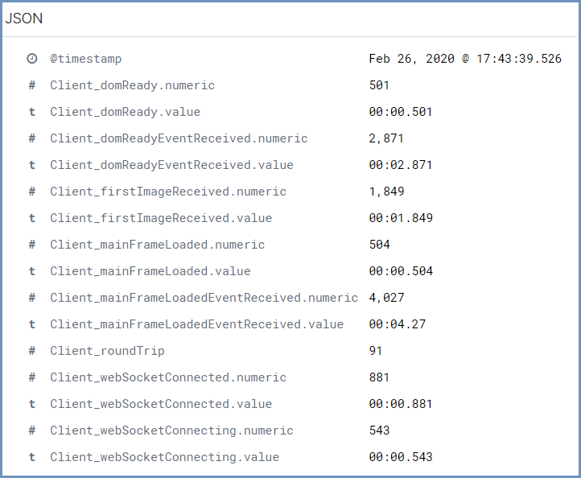

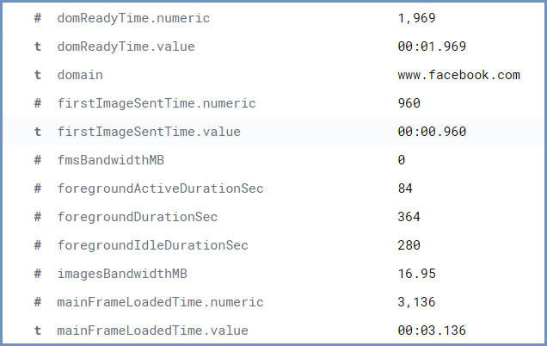

Sometimes the problem of slow loading pages is specific to a certain machine, which is not configured properly for Shield. This can be discovered using Kibana. Go to **Visualize** in the main menu.   
Create a new visualization for the **connectioninfo-\*** with a filter for a specific duration/interval field, one that would indicate a slow connection. For example, use the firstImageSentTime.numeric when greater than 2500, according to clientIP – the results will indicate which machines may have problematic configurations.